**SHARPENING**

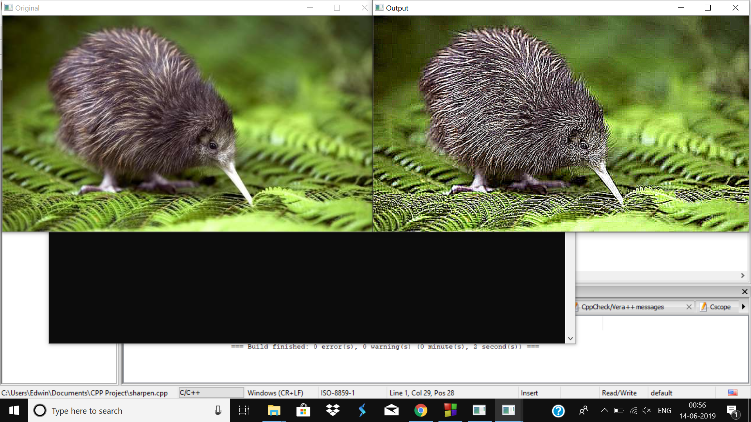

**SMOOTHENING**

